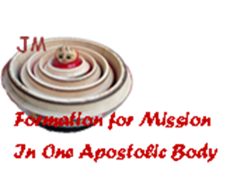
THE JOURNEY SO FAR…
THE FORMATION PROCESS

4th October 2014, Rome
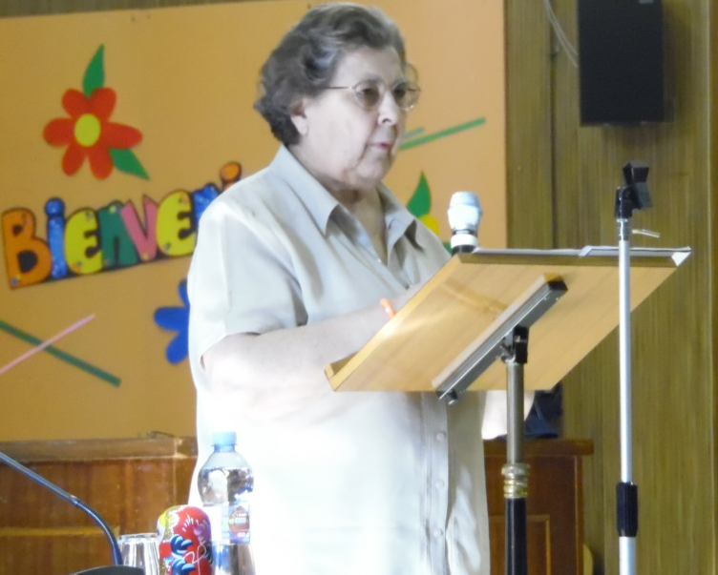
After the warm welcome and moving introduction of the first day, the 3rd and 4th of October saw us remove our sandals before the burning bush and enter the sacred ground of formation by beginning our study of the new Book of Formation. We have adopted an even work rhythm which combines moments of input with time for personal reflection and sharing in groups. This enables us to connect the theory with life experiences and also allows a process to take place at both personal and group levels.
APOSTLES FOR MISSION
Thanks to the thought provoking input and real life examples of Teresa de Jesús, rjm, we were led to consider Jesus as the model for a formator and we were reminded to keep our eyes always fixed on the horizon – the ultimate goal or reason, the FOR.
A JOURNEY TOWARDS INNER FREEDOM
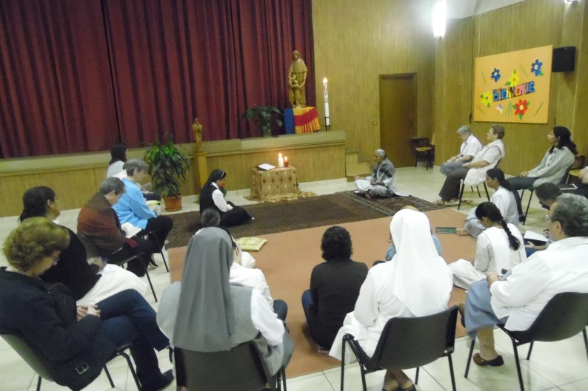
Bringing the inner dynamic of the Spiritual Exercises to life in our daily routine helps us to integrate our own lives and facilitates the gradual transformation of our senses. Accompaniment and community life help us to test and confirm the unique and personal call to the apostolic body of Jesus and Mary.
SEEKING THE ESSENCE
With all its diversity and richness, we, as formators, feel a desire to capture the very essence of religious life in the Congregation of Jesus and Mary. We perceive a need to search for common understandings and to ask the Spirit’s guidance. We are very grateful for this opportunity that we have been given to journey together in a spirit of discernment during the coming days and weeks.
And so we journey onwards… We feel called by the same Spirit and we give thanks to God today, feast of St. Francis of Assisi, for gracing us with an experience of our own poverty and limitation and with a call to entrust ourselves more and more into His hands.

