00162 Roma_____________________
Via Nomentana,325–Tel:06/841-7666
Fax.06/8586-5217

TO ALL THE RELGIOUS OF THE CONGREGATION
5th October, 2014.
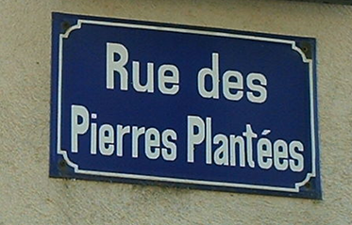
Dear Sisters,
The night of Pierre Plantees, was an unforgettable experience for Claudine.
Today, we too might be experiencing our times as a ‘night’- of violence, torture, war… with sister/brother against sister/brother. In the face of this horrendous situation, I ask myself every so often and today I share this ‘anguish’ with you – what am I doing? How are we as community reaching out? And above all, as an international congregation, what can we do at this moment in history??? The immensity of the divisions and suffering in our world can generate feelings of helplessness. True we have our heroic sisters in Syria in the forefront being ‘Claudine’ to those around, but what haunts me is … Can we do more; can I do more?
Then Claudine whispers into my ear… ‘one orphan, one loom, one woman’…nothing else… ‘one orphan, one loom, one woman…one orphan… God does the rest…and enlarges our efforts, way beyond our human calculations or expectations…as we know from the multiplication of loaves, equal wages even for the last hour of labour, the extravagance for the prodigal son….
The anguish that Claudine felt, impelled her to respond generously with the grace of God. We too need to feel intensely the anguish of our current situation, and then allow God to lead us out of our comfort zones, in however small or humble way, to nurture peace, reconciliation, justice and love…
It was truly the Holy Spirit who inspired the Captitulars to formulate the 3 Priorities, how apt they are for this time!!.
I encourage each one of you…old or young alike, to reach out to others in love and to ‘expand your tents’ with your ‘one child, one woman and one loom’ trusting in the overflowing generosity of God.
Happy Feast for the 196th Foundation day anniversary.

NEWS:
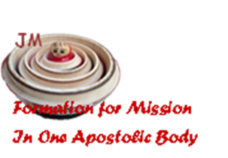
We would also like to share with you something of our life here in Rome. We have with us 26 formators from 12 provinces. Srs. Rosemary Mangan and Teresa de Jesus are the co-ordinators for this meeting. We thank you for sending all who have come, knowing the sacrifices such travel and time away entails.
The theme is Formation for Mission in One Apostolic Body.
We hope that these days will be a time of peeling one layer after another, of going deeper into the core values of the Book of Formation, of living an experience as one apostolic body, learning… providing tools to form the women of today for mission. We want our time of study, prayer, sharing and searching together to be a time of personal growth for all who take part. We desire that formation at all levels might lead to greater integration, wholeness and communion with God, with the universe, others and oneself and our hope for this time are graphically symbolized by our logo, the nesting doll or matryoshka.
Please pray for our formators and the meeting. Thank you.
Blessings and greetings from the General Team,

Monica Joseph RJM
Superior General

Ma. Carmen Munoz RJM, Ma Elizabeth Ides RJM, Irene Rodrigues RJM, Alejandra Diaz RJM
Carmen Aymar RJM and Marta Guitart RJM.

